Major General William D. Razz Waff
United States Army, Retired
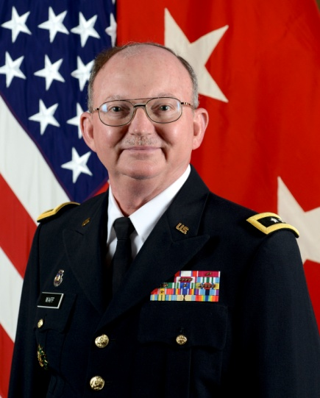
Major General William D. Razz Waff retired from the Army on 1 October 2015 with over 39 years service, with his final assignment as the Deputy G1 (Personnel) for the Department of the Army. His previous assignment was as the Commanding General, 99th Regional Support Command and Senior Commander, Ft. Devens, Massachusetts and Ft. Dix, New Jersey, headquartered at Ft. Dix, New Jersey.

As the Deputy G1, Gen. Waff was responsible for numerous personnel actions, currently focusing on the implementation of the Army Total Force Policy, coordinating the care of Wounded Warriors with Veterans Affairs and the Integrated Pay and Personnel System-Army. Additionally, he was the Chairman of the Army Reserve Forces Policy Committee.

Gen Waff began his military career by attending the Virginia Military Institute and later the University of Mississippi, graduating magna cum laude in 1976 with a bachelor of music degree. He was commissioned through the Ole Miss ROTC program as a Distinguished Military Graduate in the Regular Army as a Second Lieutenant in the Adjutant General’s Corps. While on active duty for four years at Fort Jackson, S.C., he was an Advanced Individual Training Company Executive Officer and Battalion Adjutant, 11th Battalion, 4th Advanced Individual Training Brigade. He also served as the Fort Jackson Headquarters Company Executive Officer and later as Commander; and as the Executive Officer/Adjutant of the Military Enlistment Processing Station located at Fort Jackson.

As an Army Reserve Soldier, Gen Waff has served as Training Officer of the 477th Personnel Service Com-pany, Forest Park, Illinois., and as Executive Officer of the 479th Personnel Service Company at Fort Sheridan, Ill. He has also served as the Administrative/Logistics Officer in the Composite Branch, 85th Division Maneuver Training Command (MTC) and as Chief, Personnel Services, of the MTC. He then served as the Chief, Strength Management Office, of the 85th Maneuver Exercise Command (MEC) from 1989-1992. In 1992, he became the Assistant G1 (Recruiting) for the 1st Brigade, 85th Division at Fort Sheridan, before being named G1 (Personnel) in 1994. Gen Waff was selected for battalion command in 1997 as Commander of the 1485th Logistics Support Battalion, located in Arlington Heights, Ill. In 1999, he was appointed as the Director of the Simulations Branch, Battle Projection Group, 1st Brigade, 85th Division, Arlington Heights, Ill., a position he held until his selection for command of the Second Simulation Exercise Group, 1st Brigade (BCST), 85th Division (Training Support), Fort Sheridan, Ill., in May 2000. After a successful command tour, he was then se-lected in June 2002 to serve as the Chief of Staff of the 88th Regional Readiness Command, Fort Snelling, Minn, where he served until February 2005, when he was selected for promotion to Brigadier General to serve as the Deputy Commanding General of the 99th Regional Readiness Command, Coraopolis, Pa.

Gen Waff completed the Adjutant General’s Corps Officer Basic and Advanced Courses, the Army Medical Officer Advanced Course and the Senior Officer Transportation Advanced Course. He also completed the Command and General Staff College (Resident-RC), the Army War College’s Reserve Component National Security Issues Seminar, the Army War College’s Defense Strategy Course and the Army War College’s Sen-ior Service College Course (Distance Education), being awarded the Master of Strategic Studies degree in 2001. He is also a graduate of the Department of Defense Modeling and Simulations Officer Course.

His decorations include the Distinguished Service Medal with one Oak Leaf Cluster, the Legion of Merit with one Oak Leaf Cluster, the Meritorious Service Medal with four Oak Leaf Clusters, the Joint Service Commendation Medal, the Army Commendation Medal with three Oak Leaf Clusters, the Army Achievement Medal with one Oak Leaf Cluster, the Armed Forces Reserve Medal with the Gold Hourglass Device, The Global War on Terrorism Service Medal, the National Defense Service Medal with Bronze Service Star, the Humanitarian Service Medal, the Military Outstanding Volunteer Service Medal, the Army Reserve Component Achievement Medal with nine Oak Leaf Clusters and the Army Service Ribbon, and, the Adjutant General’s Corps Regimental Association’s Horatio Gates Gold Medal and Theodore Roosevelt Medal.

He also received a Master of Divinity from Seabury-Western Theological Seminary in Evanston, Illinois in 1983, and a doctorate in medical ethics through a joint venture of the Graduate Theological Foundation and Georgetown University in 1997. His focus as a priest is healthcare chaplaincy and medical ethics.

