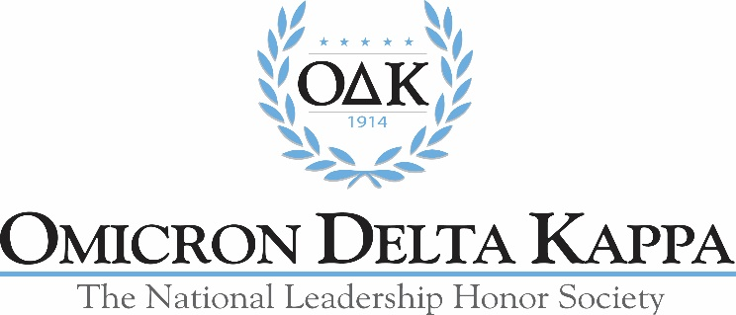
FY2020 O∆K Scholarships
Award amounts are draft recommendations based on Dec. 31, 2018 investments
and will not be confirmed until the January 2020 Board of Trustees meeting.
Scholarship Name | Criteria | Award Amount | Number Available
Auburn University Endowed Fund in memory of Dean Cater | Top applicant from Auburn | $1,000 | 2
Blount | Top applicant from Alabama | $2,000 | 1
Chellegren Family | None specified | $1,500 | 1
Eastern Kentucky University | Top applicant from EKU | $1,000 | 1
Scott R. Goodale Memorial | Top applicant representing the athletics phase | $1,000 | 1
Rupert Latture | None specified | $1,500 | 1
Louise and William Latture Scholarship | From an institution in the South | $1,000 | 1
John D. Morgan | Top undergraduate applicant | $2,500 | 1
Karlem Reiss | Top applicant from Louisiana | $1,000 | 1
University of Miami in Memory of Laura Morgan (first payment in FY20 | Top applicant from the University of Miami | $1,000 | 1
University of Richmond Endowed Fund in honor of Steve Bisese | Top applicant from the University of Richmond | $1,000 | 1
Diane and Tom Vukovich | Top applicant from Ohio | $1,500 | 2 for $1,500 each
Washington and Lee University Endowed Fund in honor of Ken Ruscio | Top applicant from Washington and Lee | $1,000 | 1
General Scholarships | None specified | $1,000 | 19
Total for FY20 |  | $37,500 | 34

