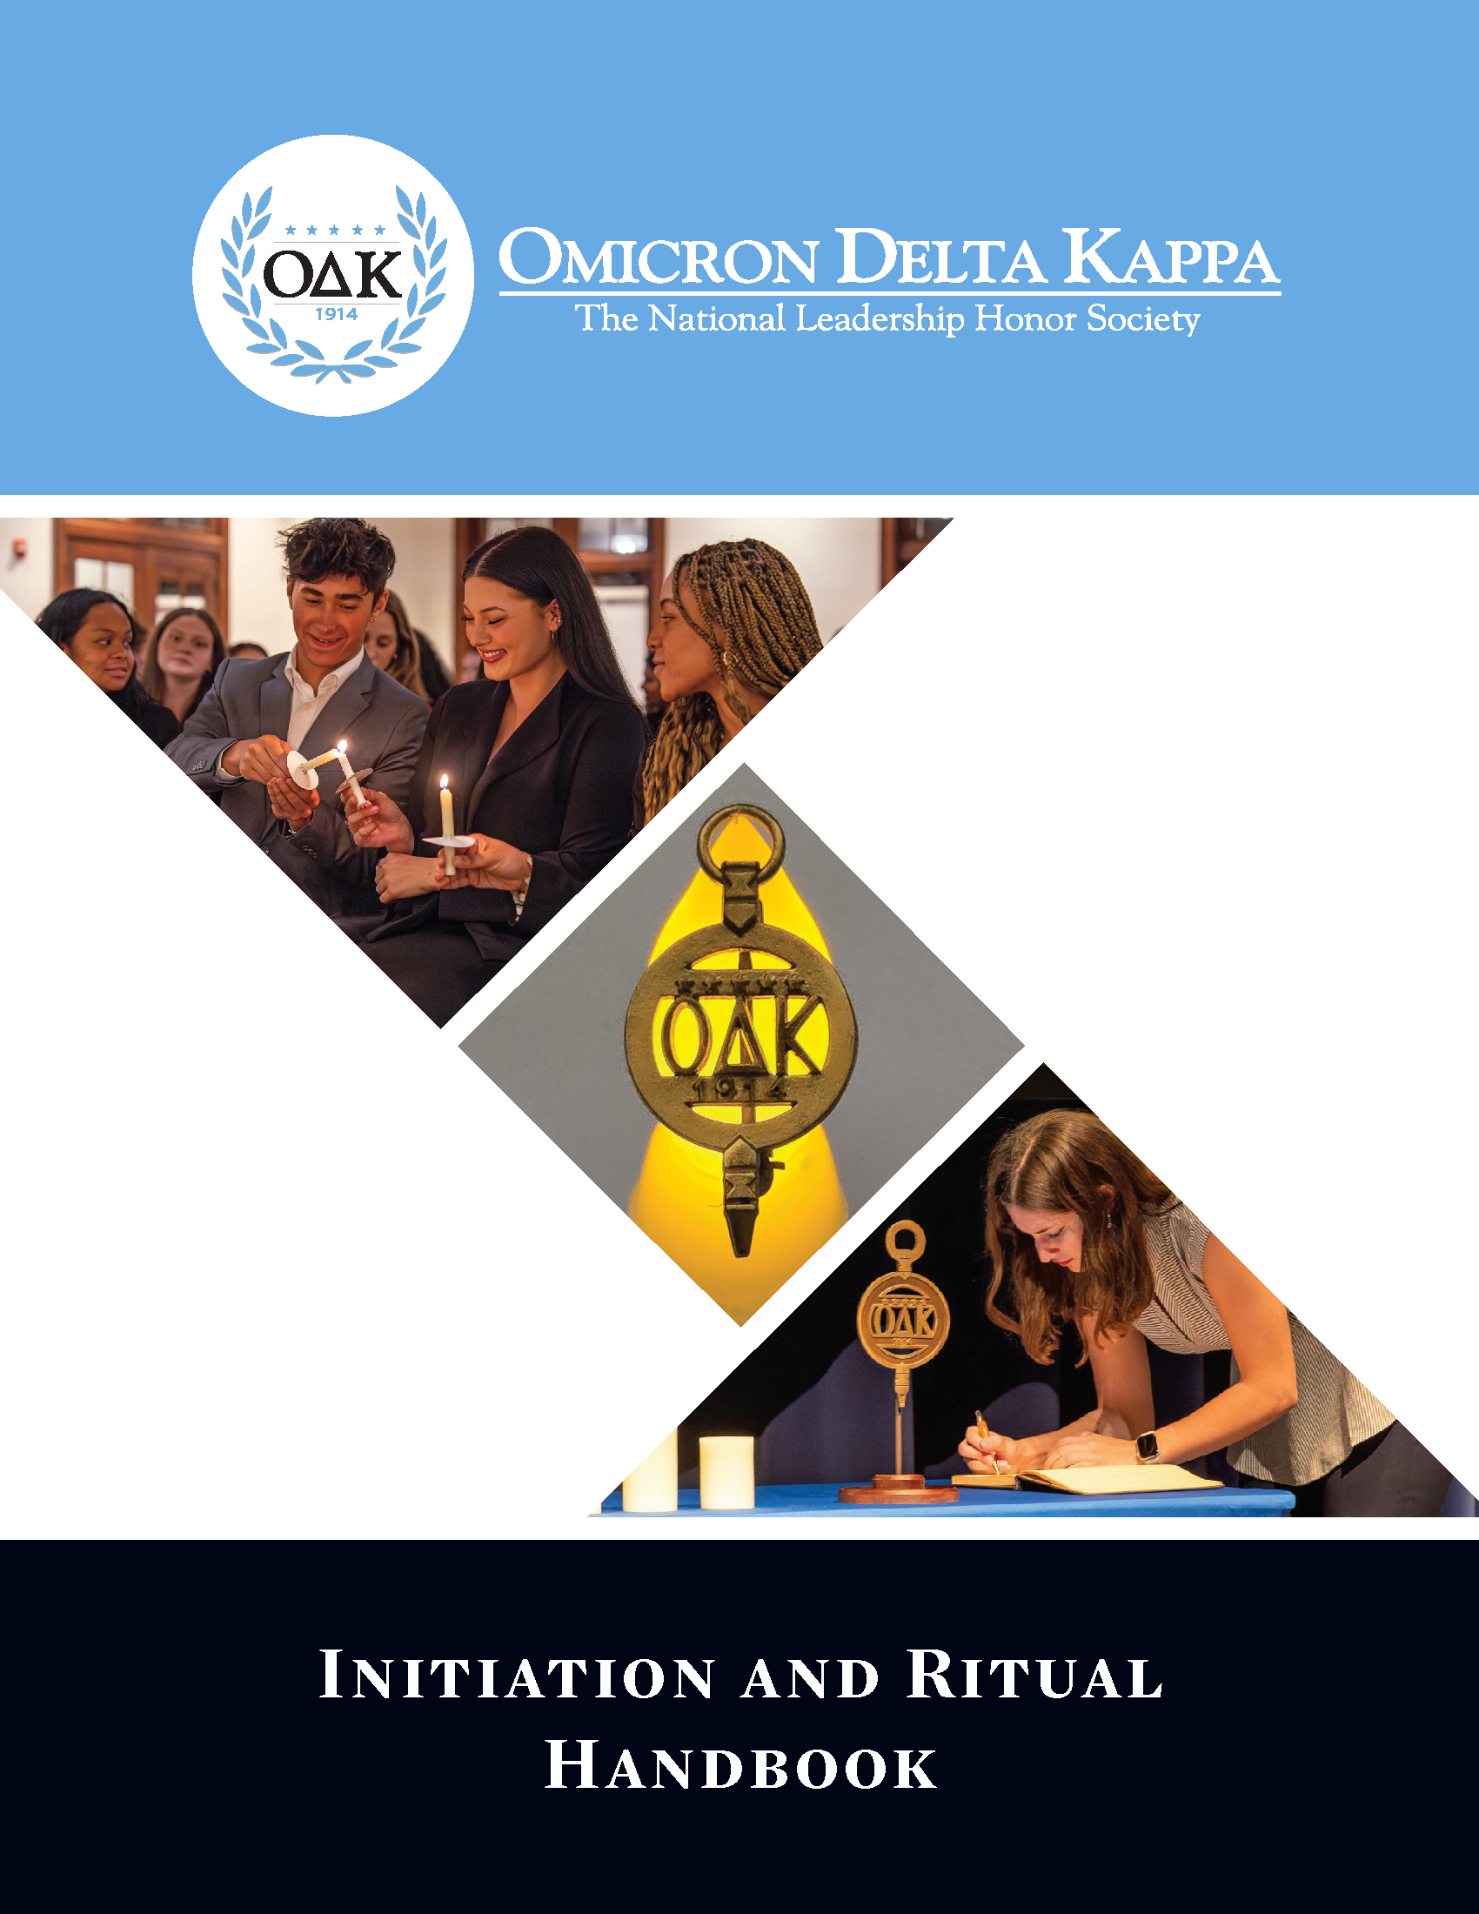

GENERAL INSTRUCTIONS AND INFORMATION

- The official Omicron Delta Kappa Initiation Ceremony has six distinct parts:

  - Processional
  - Introduction
  - History and Values
  - Symbols
  - The Ritual
  - Installation of Officers
  - Closing and Recessional

- Omicron Delta Kappa initiation and installation ceremonies are public celebrations. They are formal ceremonies and should be treated with respect and dignity.
  - Circles are encouraged to invite friends/family members, local O∆K lifetime/alumni members, and O∆K circles in the region.
  - Circles are also encouraged to send invitations to chief institutional officers
  - This handbook provides alternative language for the start and conclusion of the initiation ceremony.

- All members of the circle shall assemble at the appointed place, all wearing business attire or academic regalia.
  - Circle officers and faculty/staff members should have roles within the ceremony.
  - Members of the circle should have roles in the ceremony such as Voices, marshals, greeters, etc.
  - The three “Voices” may speak from appropriate places at the initiation table or from the rear of the room or a balcony

- Ceremony Space: Reserve a large room that holds the expected number of inductees and guests for the ceremony, and arrange the space to be as attractive as possible.

- The “Stage”: The stage area consists of a head table, podium, and seating for the presiding officer and other officers.
  - A table of suitable size will serve as a focal point for the ceremony.
  - Drape the table with an O∆K tablecloth, plain tablecloth, or sheet; if using a plain tablecloth, place an O∆K podium cloth at the front, [8] or on a free-standing podium [1]
  - Place the O∆K Key in the center of the table [2]
  - Place five white long-stemmed candles on the back left corner [3] (electric candles are acceptable)
  - Place the circle record book on the front right corner [4]
  - Place pins and certificates on the front left corner [5] [6]
  - Place a bowl or vase filled with flowers (white and/or blue) on the table [7] (the official flower of Omicron Delta Kappa is the blue delphinium)

- Seating: The candidates for initiation should be seated in the front of the room in alphabetical order matching the reading of the names.
  - Rows should be spaced far enough apart to allow for easy movement of candidates to and from the stage.
  - If the room has fixed auditorium seating, consider using seating marshals. Marshals ask a row of candidates to stand and move to the side of the room in a row to receive their emblems. The Marshals direct candidates back to their seats. This improves movement in the room and makes the ceremony more enjoyable for all.

- Processional and Recessional: Candidates for induction shall assemble in an adjacent room prior to the ceremony.
  - Upon direction of the Circle President or Presiding Officer, designated guides lead candidates into the room; as the procession approaches the draped table, installing/circle officers take their places directly behind it; inductees should take their seats.
  - At the end of the ceremony, the new initiates and officers recess from the room before the guests.

- Music: Music or an electronic presentation may be a part of the ceremony. Use of the instrumental version of “Proud to Be O∆K” is recommended.

- Reception: Circle may assemble for a reception or banquet before or after the ceremony.
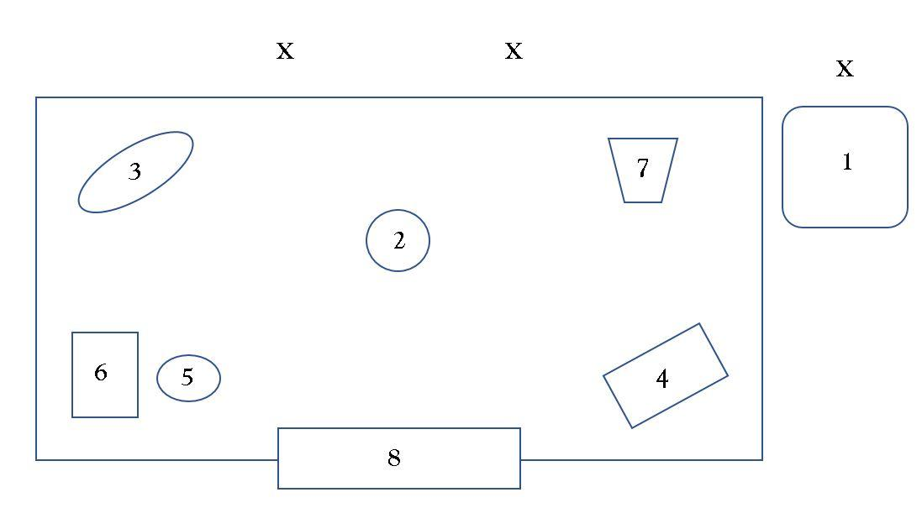
- Materials List
- Free-standing or table podium
- O∆K Key
- Five white long-stemmed candles
- Record book and pen
- Pins
- Certificates
- Flowers
- Podium cloth
x = Installation officer(s)
INITIATION CEREMONY
PROCESSIONAL
(Candidates for membership process into the room led by the officers and other university officials or special guests.)

Introductions and Welcome
(Introductory comments and a general welcome may be given by the President/Presiding Officer or another individual as individuals gather for the start of the ceremony.)

INTRODUCTION
Presiding Officer: As the _______________ of the __________________ Circle of
Title Name of Institution
Omicron Delta Kappa, I formally call this initiation ceremony to order.
Candidates for membership, we invite you to participate in this ritual of membership held on your behalf. As members of OΔK, we value its high ideals and purposes as we strive to provide leadership in worthy undertakings and to be of service to others. We believe in the mission, vision, and values, of this Society.

We are pleased and honored to share them with you today as we welcome you into the (Name of Institution) Circle of Omicron Delta Kappa at [Name of Institution].
Let us welcome ____________________________ who will lead our [invocation] or
Name of Individual
[opening moment of reflection].

(Circles should use the Invocation or Opening Moment of Reflection, but not both.)
Invocation: O God, we are grateful for the privilege of leadership in worthy undertakings and for the ideals of Omicron Delta Kappa. As we gather to confer the honor of membership upon these duly elected individuals, give to all assembled here a renewed vision of the meaning of Omicron Delta Kappa.

Grant that the desire for creative thinking, for high purposes and ideals, for moral strength and integrity may ever remain close to our hearts. Grant also that we may strive without ceasing to incorporate them into our lives as students, faculty, staff, alumni, and civic leaders. Instill in us, O God, the principles of faith and courage, of honest work, and of sacrifice for the tasks that lie before us. Amen.
Or

Opening Moment of Reflection: We are grateful for the privilege of leadership in worthy undertakings and for the ideals of Omicron Delta Kappa.

As we gather to confer the honor of membership upon these duly elected individuals, we hope that all assembled here will find a renewed vision of the meaning of Omicron Delta Kappa.

Grant that the desire for creative thinking, for high purposes and ideals, for moral strength and integrity, may ever remain close to our hearts.

Grant also that we may strive without ceasing to incorporate them into our lives as students, faculty, staff, alumni, and civic leaders.

Instill in us the principles of faith and courage, of honest work, and of sacrifice for the tasks that lie before us.

HISTORY AND VALUES
Presiding Officer: Today, you accept the obligation of membership in Omicron Delta Kappa. As members, you pledge to be an uplifting presence during your time at this institution, and throughout your life. As a member, you commit that you will make every effort to practice its high ideals, both in private and public life, so that the world may see in you a concrete, living symbol of the great principles of Omicron Delta Kappa.

Omicron Delta Kappa (O∆K) was founded on December 3rd, 1914, at Washington and Lee University, in Lexington, Virginia. Our 15 founders stated that leadership of exceptional quality and versatility in college should be recognized; that representatives of all pillars of college life should cooperate in worthwhile endeavors; and that outstanding students and faculty members should meet on a basis of common interest, understanding, and helpfulness.

Our founders had a vision: to unite leaders from all corners of campus life for the good of their institution. They created something unique - a Society where students and faculty stand as equals, recognizing and celebrating exceptional leadership. The founders envisioned O∆K as a union of student, faculty, staff and alumni leaders that would be a force for constructive influence. This vision, which we call the O∆K Idea, proved so powerful that it spread to colleges and universities across the nation, with each new chapter known as a circle.

The Society in which you are about to become a member has a three-pronged mission:
- Identify, honor, and develop leaders in collegiate and community life;
- Encourage collaboration among students, faculty, staff, and alumni to advance leadership; and
- Promote, publicize, and enhance our ideals.

The Society’s ideals are represented by our five leadership values:
(As each of the five leadership values is stated slowly and emphatically by the Presiding Officer, an assistant lights one candle at a time until all five candles are lit.)

- Collaboration – to work together to achieve a defined and common purpose
- Inclusivity – to actively seek, embrace, and advance a diverse group of individuals
- Integrity – to align one’s values and beliefs with behaviors and speech
- Scholarship – to strive for excellence in academics and to pursue lifelong learning
- Service – to answer the call for action from one’s community or country

SYMBOLS
The Key
It has ever been our desire and custom to try to symbolize in material form our dreams, ambitions, ideals, and sentiments. In accordance with this innate desire and feeling, Omicron Delta Kappa has also tried to express in material form, the "Key," its noble ideals, lofty aspirations, and altruistic aims. The Key, which is struck in the form of a circle, symbolizes union forever and the equality which characterizes membership in Omicron Delta Kappa.

The shape of the Key (the Presiding Officer points to a large replica of the Key) represents the circle, which symbolizes the all-around and inclusive nature of our organization. The five stars on the upper bar represent the five major pillars of college life, for which our Society stands:
- Academics and Research
- Athletics
- Service to Campus and Community
- Communications
- Creative and Performing Arts
The number 1914 on the lower bar indicates the year in which our Society was founded.

The Crest
Our emblem, or Crest, is the Laurel Crowned Circle. This stands for success achieved in worthy undertakings.
The Greek motto for which the letters O∆K stand is “Ho daf No' koe mose Kook'-loss” which translates as "The Laurel Crowned Circle."

The Circle
(At this point, the Presiding Officer should add a brief statement about the history or traditions of the local circle such as charter date, major circle programs, and distinguished members.)

INITIATION RITUAL
Presiding Officer: We who are members of Omicron Delta Kappa have observed your habits, attitudes, and capacities.
We are pleased with your success, your steady growth as leaders, and your appreciation of the ideals and purposes of the Society.
We have asked you here today to make you members of our Society and to present to each of you the symbol of achievement, the Key of Membership.
Before we accept you into the Omicron Delta Kappa Society, please listen thoughtfully to these words.
(The three voices may speak from appropriate places at the initiation table
or from the rear of the room or balcony.)

First Voice: You should know that the Key of Membership is not only a recognition of past exemplary conduct, but that it must also be to you a constant inspiration to finer and nobler living, so long as you shall live.

Second Voice: You should know that the Key of Membership is not only a recognition of past loyalty to all good works, but that it must also be a constant inspiration to unselfishly serve Omicron Delta Kappa, your alma mater, your vocation, and your community. Let it be a life-long reminder that if greatness is to be achieved, one must serve.

Third Voice: You should know that the Key of Membership is not only a recognition of past achievement, but that it must also be a constant inspiration to spend the rest of your days climbing higher and yet higher, ever remembering that death comes apace, and that the longest span of human life is all too short for the completion of the tasks that lie before us.
The Oath
Presiding Officer: Will the candidates for membership please stand, if you are able? You have heard in these words the great, unchanging principles upon which our Society is founded. If you are willing to accept the lofty ideals, the sense of devotion, and the spirit of aspiration represented in Omicron Delta Kappa, please respond, “I will.”

Candidates: I will.

The Pledge
Presiding Officer: Then, please repeat after me.
(State each line slowly and clearly waiting for all initiates to finish before starting the next line.)
"In the presence of the Circle here assembled,/
I solemnly promise/
to uphold the Ideals and Traditions,/
to follow the requirements of the National Bylaws,/
of the Omicron Delta Kappa Society,/
and to support in loyal service/
its local and national officers,/
to participate in its meetings, ceremonies, and initiatives,/
and to diligently foster/
life-long leadership."

You may be seated.

Presiding Officer: You have committed yourself to the principles of the Omicron Delta Kappa Society and to our timeless leadership values of collaboration, inclusivity, integrity, scholarship, and service. From this day forward and throughout each stage of your life, you will strive to serve as a living example of excellence in leadership.

Presentation of the Key of Membership and Certificate
Presiding Officer: You have been chosen to wear the Key of Membership as an emblem of distinction. This symbolizes your loyalty and devotion to excellence in leadership and to the things that are fine and true in life. Whenever possible, wear this pin with pride to demonstrate the honor bestowed upon you today. As your name is called, come forward to sign the Official Record of the ________________
Name of Institution
Circle and receive your Certificate and Key of Membership in our Society.
(The Presiding Officer or designee shall call each member forward by name
and deliver to each one the symbols of membership in the Society.)

[Insert the names of those being initiated.]

(It is recommended that the list of names include the phonetic spelling of each name so
officers can pronounce the name of each initiate correctly.)

(Wait until all initiates have received their emblems and are seated to proceed.)

Presiding Officer: Congratulations!

As newly inducted members of our Society, you have taken upon yourselves the obligations of membership. We hope you will take with you – and incorporate into your daily lives – the ideals of excellence in leadership and service that we have affirmed here today.
(Proceed to the Installation of Officers if appropriate. If not, proceed to the conclusion of the ceremony, which includes the benediction/closing moment of reflection.)

INSTALLATION OF OFFICERS

President/Presiding Officer:
I now ask that the incoming officers of the (Name of Institution) Circle of O∆K come forward to take the oath of office.

President: _________________________________
Vice President: _________________________________
Circle Coordinator: _________________________________
Faculty Advisor: _________________________________
Treasurer: _________________________________
(Additional officers may be sworn in if selected by the circle.)

Presiding Officer: Please raise your right hand and repeat after me.
(State each line slowly and clearly waiting for all initiates to finish before starting the next line.)

“I do solemnly promise/
That I will discharge the duties of my office/
In accordance with the local and National Bylaws/
To the best of my knowledge and abilities/
Bearing in mind always/
The welfare of my alma mater/
And of the Omicron Delta Kappa Society.”

Presiding Officer: Congratulations! We thank our outgoing officers for their work over the past year and welcome the new officers.
CLOSING AND RECESSIONAL
(Before concluding the ceremony, circles are invited to sing “We’re Proud to be O∆K.” An audio file containing the musical accompaniment and sheet music are available at odk.org.)

Presiding Officer:
To conclude the ceremony, let us welcome ____________________________
Name of Individual
(Circles should use the Benediction or Closing Moment of Reflection, but not both.)

Benediction: Most gracious God, our eyes are open to all lovely objects of righteousness and truth, and we have been blessed with courage and enthusiasm, high impulse and lofty thought. In this, our hour of great dedication, help us as we go out into the world to keep fresh in our lives the ideals which we have affirmed here today. Amen.
Or
Closing Moment of Reflection: Our eyes are open to all lovely objects of righteousness and truth, courage and enthusiasm, high impulse, and lofty thought. In this, our hour of great dedication, let us go out into the world and keep fresh in our lives the ideals which we have affirmed here today.

(New initiates recess from the room led by the officers and other university officials or special guests.)

